**Columbian Exchange**

**Given all of the consequences, was the Columbian Exchange initiated by the Old World overall more positive or negative?**

**Document #l:** Map, *The Columbian Exchange*

Background: Few events transformed the world like the Columbian Exchange. This global transfer of plants, animals, disease, and especially food brought together the Eastern and Western hemispheres and touched, in some way, nearly all peoples of the world.

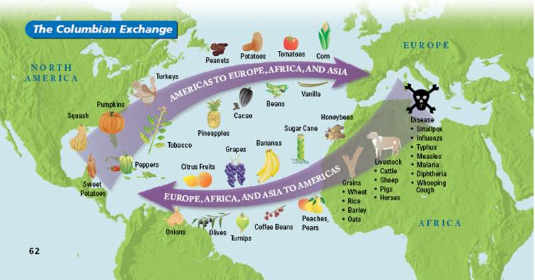

**Document #2:** An excerpt from Columbus's personal journal by Bartolome de Las Casas

Background: The arrival of Christopher Columbus in the Caribbean in 1492 had a tremendous impact on the future of that region. The passage below describes that arrival.

|  |
| --- |
| The Admiral ... called them as witnesses to certify that he in the presence of them all, was taking, as he in fact took possession of said island for the King and Queen his masters, making the declaration that were required they will be found more fully in the attestations then taken down in writing. Soon after a large crowd of natives congregated there. What follows are the Admiral's own words in his book on the first voyage and discovery of these Indies. *"In order to win the friendship and affection of that people, and because I was convinced that their conversion to our Holy Faith would be better promoted through love than through force, I presented some of them with rep caps and some strings of glass beads which they placed around their necks, and with other trifles of insignificant worth that delighted them and by which we have got wonderful hold on their affections."* |

**Document #3:** An image drawn in the mid - to late 1500s by a Spanish Friar named Bernardino de Sahagun from his *General History of the Things of New Spain.*

Background: Among the most disastrous effects of Europeans in the Americas *was* the rapid spread of disease. Historians estimate that about 90 percent of the Native American population was killed by diseases like smallpox, influenza, and malaria. This image shows Aztecs suffering through various stages of smallpox.

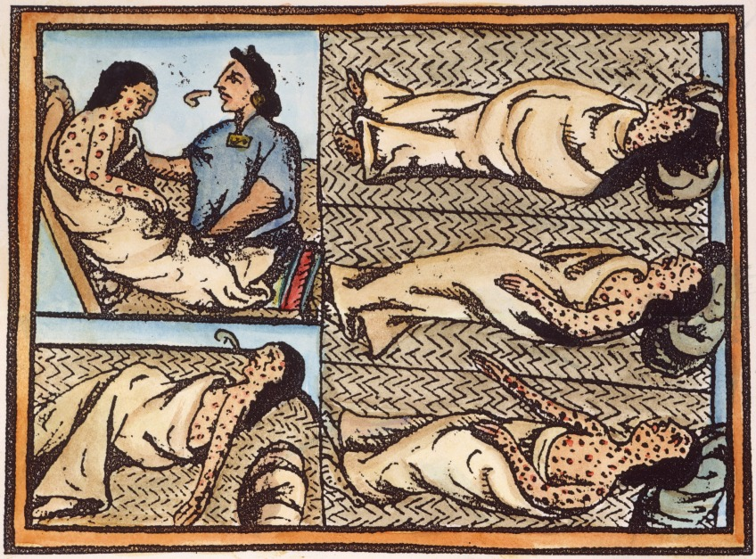

**Document #4-** An excerpt from the Columbus’s journal, translated by Robert H. Fuson.

Background: The arrival of Christopher Columbus in the Caribbean in 1492 had a tremendous impact on the future of that region. The passage below describes one of his personal encounters.

|  |
| --- |
| During this time I walked among the trees, which were the most beautiful I have ever seen. I saw as much greenery, in such density, as I would have seen in Andalusia in May. And all of the trees are as different from ours as day is from night, and so are the fruits, herbage, the rocks, and everything....  There are trees ... that give fruit like apricot, which is full of small seeds like the seeds of fig, red as scarlet which the inhabitants eat, but it is none too good.... There are also some like artichoke plants but four times as tall, which gives a fruit in the shape of a pine cone, twice as big, which fruit is excellent, and it can be cut with a knife and it seems to be very wholesome....  All the land around the village is cultivated, and a river flows through the middle of the valley. It is very large and wide and could irrigate all the land around. All the trees are green and full of fruit, the plants are in flower and very tall. The roads are wide and good, and the breezes are like those in Castile in the month of April. The nightingales and other small birds sing as they do in Spain in the month, and it is the greatest pleasure in the world. Small birds sing sweetly during the night, and one can hear many crickets and frogs. The fish are the same as in Spain. There are many mastic trees and aloes and cotton trees. |

**Document #5** – An excerpt from writing by Barolome de Las Casas and corresponding illustration.

Background: Las Casas was an early Spanish missionary who watched fellow Spaniards unleash attack dogs on Native Americans.

*"Their other frightening weapon after the horses: twenty hunting greyhounds. They were unleashed and fell upon the Indians at the cry of 'Toma/of' ["Get Them!"]. Within an hour they hod preyed on one hundred of them. As Indians were used to going completely naked, it is easy to imagine what the fierce greyhounds did, urged to bit naked bodies and skin much more delicate than that of the wild boars they were used to ... This tactic, begun here and invented by the devil, spread throughout these Indies and will end when there is no more land nor people to subjugate and destroy in this part of the world."*

[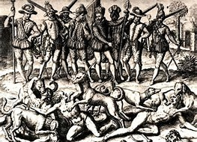](http://www.bing.com/images/search?view=detailV2&ccid=q6i83u7K&id=87503D541B1FE889432A22DD53B54B85EEF16017&thid=OIP.q6i83u7KVaDd-XZpXgGXyQEsDc&q=Bartolome+de+las+casa+dogs&simid=608016771852864002&selectedIndex=29)

**Document #6:** Opposing viewpoints from historians, during the 20th Century.

Background: Historians have differed widely over the impact of Columbus on world history. Was he a hero who ushered in economic well-being throughout the world? Or, was he a prime mover in the destruction of the people and cultures of the Americas?

|  |
| --- |
| "The whole history of the America stems from the Four Voyages of Columbus... Today a core of independent nations unite in homage to Christopher, the stout­ hearted son of Genoa, who carried Christian civilization across the Ocean Sea."  ---Samuel Eliot Morison, 1942  "Just twenty-one years after Columbus's first landing in the Caribbean, the vastly populous island that the explorer had re-named Hispaniola was effectively desolate; nearly 8,000,000 people ... had been killed by violence, disease, and despair. What happened on Hispaniola was the equivalent of more than fifty Hiroshimas.* And Hispaniola was only the beginning."  ---David E. Stannard, 1992  *The atom bomb dropped on Hiroshima, Japan killed at least 130,000 people.  "When the two races first met on the eastern coast of America, there was unlimited potential for harmony. The newcomers could have adapted to the hosts' customs and values....But this did not happen ... [Columbus] viewed the natives of America with arrogance and disdain ... Columbus wrote of gold,  ... and of spices, ... and 'slaves, as many as they shall order to be shipped ... "'  ---George P. Horse Capture, 1992 |

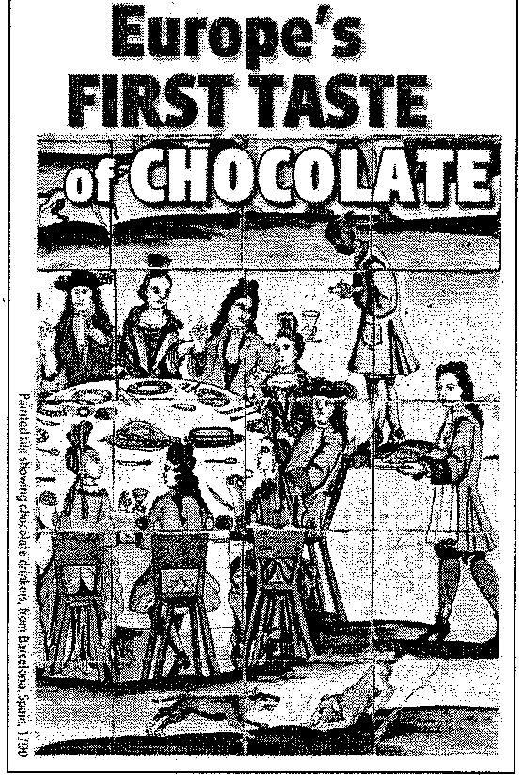**Document #7** – Illustration “Europe’s First Taste of Chocolate

**Background:** The tasty secret of the cacao (Kah Kow) tree was discovered 2,000 years ago in the tropical rainforests of the Americas. The pods of this tree contain seeds that can be processed into chocolate. The story of how chocolate grew from a local Mesoamerican beverage into a global sweet encompasses many cultures and continents.

The first people known to have made chocolate were the ancient cultures of Mexico and Central America. These people, including the Maya and Aztec, mixed ground cacao seeds with various seasonings to make a spicy, frothy drink.

Later, the Spanish conquistadors brought the seeds back home to Spain, where new recipes were created, and eventually the drink's popularity spread throughout Europe. Since then, new technologies and innovations have changed the texture and taste of chocolate, but it still remains one of the world's favorite flavors.

**Document 8- A New Economic System**

When they established colonies in the Americas, the Spanish created a new economic system, the encomienda system, in which Native Americans worked on Spanish-owned estates. The basis for that system was laid out in a letter from King Ferdinand and Queen Isabella to the governor of Hispaniola in 1503.

“Our desire is that the Christians not lack people to work their holdings and to take out what gold there is. It also is our desire that the Indians live in community with the Christians, because they then will help each other cultivate and settle the island, take out the gold, and bring profit to Spain. Therefore, we command you, our governor, to compel the Indians to associate with the Christians. The Indians should work on the Christians’ building, mind the gold, til the fields, and produce food for the Christians. This the Indians shall perform as free people, which they are, and not as slaves. Also, see to it that the Indians are well treated, with those who become Christians better treated than the others. Do not consent or allow any person to do them any harm or oppress them.”

**Document 9- Religion and Language**



**Document 10- Technology**

